

24ADC001- BUSINESS INTELLIGENCE

TEJASRI V (24BAD124)
--------------------------------------------------

2026-2027
LAB RECORD

DEPARTMENT OF ARTIFICIAL
INTELLIGENCE AND DATA SCIENCE

INDEX
Expt. No | Title of the Experiment | Page No | Total  Marks | Faculty Signature
1. | Explore the interface and basic features of the BI tool
2. | Load and visualize a sample dataset.
3. | Import a dataset into the BI tool. And Cleanse data by handling missing values, outliers, and inconsistencies.
4. | Transform data to suit BI reporting requirements and Design a dashboard with key performance indicators (KPIs).
5. | Develop interactive dashboards for dynamic data exploration.
6. | Integrate data from various sources for comprehensive analysis
7. | Implement advanced chart types (treemaps, heatmaps, etc.).
8. | Apply BI tools for forecasting and predictive analytics.

Average marks Faculty Signature

EXPT NO:1 | EXPLORE THE INTERFACE AND BASIC FEATURES OF BI Tool
DATE: 10.07.2026

PRE-LAB QUESTIONS (PROVIDE BRIEF ANSWERS TO THE FOLLOWING QUESTIONS)

- What is the purpose of Business Intelligence (BI) tools like Tableau and Power BI?
Business Intelligence tools such as Tableau and Power BI help convert raw data into meaningful information. They allow users to analyze large datasets, identify trends, and present insights through charts and dashboards, making it easier for organizations to make informed decisions.
- List any three common data sources that Tableau and Power BI can connect to.
Tableau and Power BI can connect to many data sources. Three common ones are:
- Microsoft Excel files
- SQL databases
- CSV files

- What is a dashboard in BI, and how is it different from a single chart?
A dashboard is a collection of multiple visualizations, KPIs, and filters displayed together on one screen to provide a complete overview of data. A single chart, on the other hand, shows only one specific aspect of the data, such as sales, profit, or stock price.

- Define the following terms:
  - Visualization
  - KPI
  - Data Filter

a) Visualization: A visualization is the graphical representation of data using charts, graphs, maps, or other visual elements to make information easier to understand.

b) KPI: A KPI (Key Performance Indicator) is a measurable value used to evaluate how effectively an individual, team, or organization is achieving a specific objective.

c) Data Filter: A data filter is a tool that allows users to display only the relevant portion of data by applying certain conditions, such as date, category, or region.

- Why is it important to clean and transform data before visualization?
Cleaning and transforming data is important because raw data may contain errors, missing values, duplicates, or inconsistent formats. If such issues are not corrected, the visualizations may give misleading results. Properly prepared data ensures accurate analysis and reliable decision-making.

- What kind of chart would you use to analyze stock price trends over time?
A line chart is the best choice for analyzing stock price trends over time because it clearly shows how prices rise and fall across different dates.

- Explain the role of slicers in Power BI and filters in Tableau.
Slicers in Power BI and filters in Tableau help users interact with the data by narrowing down the information displayed in a report or dashboard. For example, they can be used to view data for a particular stock, year, or region without changing the original dataset.
- What does a calculated field or measure do in BI tools?
A calculated field or measure performs a custom calculation on existing data. It is used to create new values, such as profit percentage, average sales, or prediction error, which are not directly available in the original dataset.

- What are the advantages of using interactive dashboards for financial data analysis?
Interactive dashboards are useful in financial data analysis because they allow users to explore data from different perspectives. They help identify trends, compare performance, monitor KPIs, and make faster decisions by providing real-time insights in a visual and easy-to-understand format.

- Which function would you use to find the absolute difference between predicted and actual stock prices?
To find the absolute difference between predicted and actual stock prices, the ABS() function is used.
Example: ABS(Predicted Price - Actual Price)
This function removes the negative sign and gives the exact difference between the two values.

IN-LAB EXERCISE:
Objective:
To understand the basic interface, data import process, and fundamental visualization capabilities of Tableau and Power BI using a stock prediction dataset, and to explore their usefulness in analyzing financial data.

Tools Required:
- Tableau Public / Tableau Desktop
- Power BI Desktop
- Sample Dataset (CSV/Excel) containing:
Date, Stock Name, Open, Close, High, Low, Volume, Predicted Price

Exercise Steps:
Part 1: Working with Tableau
- Launch Tableau and connect to the stock prediction dataset.
- Explore the Interface: o Understand components like Data Pane, Sheets, Marks Card, and Dashboards.
- Create Basic Visualizations:
  - Line Chart: Show Close Price over time. o Scatter Plot: Plot Volume vs. Predicted Price.
  - Highlight Table: Display Predicted Price by stock.
- Apply Filters:
  - Add filters for Stock Name and Date Range.
- Create Calculated Field: o Calculate prediction error as |Predicted - Close|.
- Design a Basic Dashboard:
  - Combine your charts into one interactive dashboard.

Part 2: Working with Power BI
- Open Power BI Desktop and import the same dataset.
- Explore the Interface: o Familiarize with Fields Pane, Visualizations Pane, Report View, Data View.
- Create Basic Visualizations:
  - Line Chart: Trend of Close Price over time.
  - Bar Chart: Compare Predicted Price vs. Close Price.
  - Card (KPI): Display average prediction error.
- Use Filters and Slicers:
  - Filter data based on Stock Name and Date.
- Create a Simple Measure using DAX:
  - Example: Prediction Error = ABS(Predicted - Close)
- Build a Report Page:
  - Arrange visuals in a single interactive page.

TABLEAU DASHBOARD:

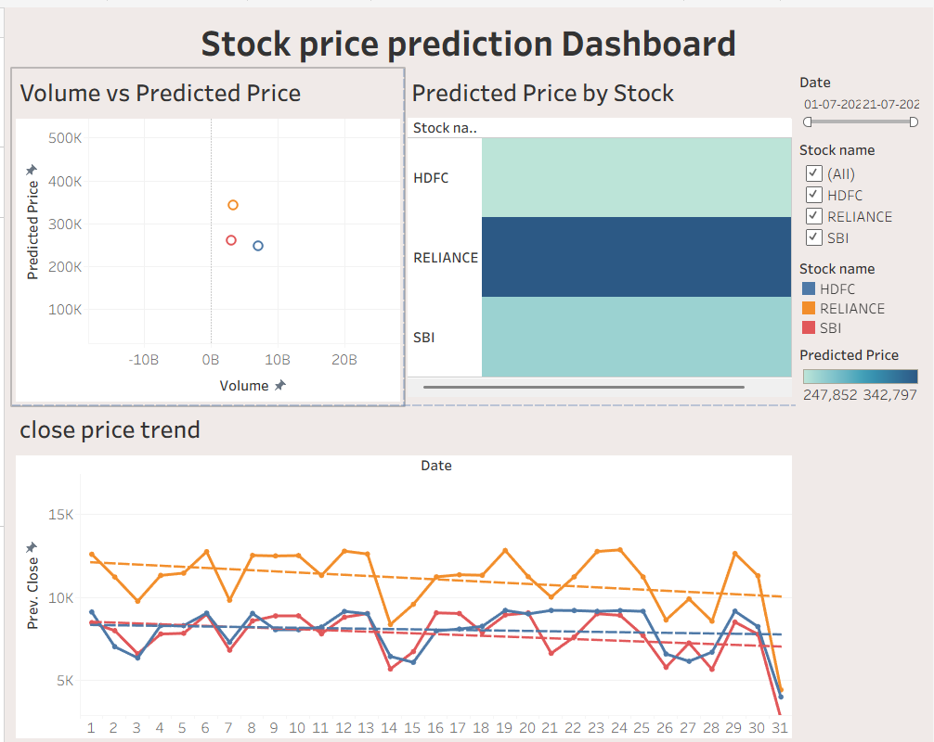

POWER BI DASHBOARD:

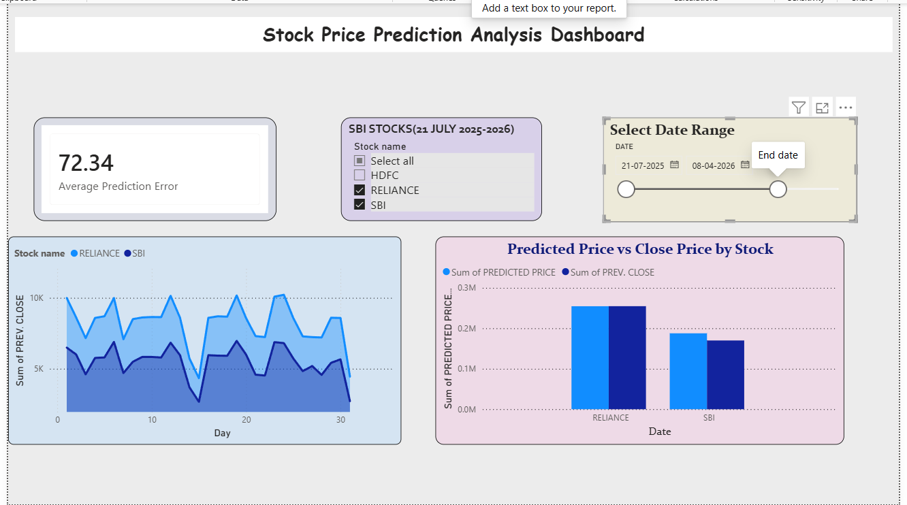

POST-LAB QUESTIONS (PROVIDE BRIEF ANSWERS TO THE FOLLOWING QUESTIONS) :

- Describe your experience with the Tableau interface. What components did you interact with?
The Tableau interface provides an interactive and user-friendly environment for data analysis. Key components include the Data Pane, Rows shelf, Columns shelf, Marks card, Filters shelf, and Dashboard workspace, which together support efficient visualization and dashboard creation.

- How did you import the dataset into Tableau and Power BI?
Datasets are imported into Tableau through the Connect to a File option, while Power BI uses the Get Data feature. Both tools allow users to load CSV files and preview the dataset before analysis.

- What types of visualizations did you create in both tools? List at least two per tool.
Common visualizations created in Tableau include line charts and scatter plots. In Power BI, line charts and bar charts are commonly used to represent trends and comparisons in financial data.

- How did you calculate the prediction error, and how was it displayed in your dashboard?
The prediction error is calculated using the formula ABS([Predicted Price] - [Close]), which determines the absolute difference between predicted and actual closing prices. This metric is displayed in the dashboard to evaluate prediction accuracy.

- Which filtering or slicing techniques did you apply, and what insights did they reveal?
Stock Name and Date Range filters are commonly applied to refine the analysis. These filters help in examining specific stocks, selected time periods, and comparative performance trends.
- Compare the process of creating a line chart in Tableau vs. Power BI. What differences did you notice?
In Tableau, line charts are created by dragging fields to the Rows and Columns shelves. In Power BI, line charts are created by selecting the visual type and assigning fields to the X-axis and Y-axis. Tableau emphasizes shelf-based design, while Power BI emphasizes visual configuration.
- How did you organize the dashboard in Tableau and Power BI? What key elements did you include?
A professional dashboard is organized with filters at the top, primary charts in the central area, and supporting tables or visualizations at the bottom. This layout ensures clarity, accessibility, and effective data presentation.

- Which tool (Tableau or Power BI) did you find more user-friendly for financial data visualization, and why?
Tableau is often considered more user-friendly for exploratory data visualization due to its intuitive drag-and-drop interface, while Power BI is valued for its seamless integration with Microsoft tools and business reporting features.

- What challenges did you face while creating visualizations or dashboards?
Common challenges include applying filters across multiple worksheets, arranging dashboard components effectively, creating calculated fields accurately, and ensuring proper interaction between visualizations.

- How can the knowledge gained from this lab be applied to real-world financial data analysis?
The knowledge gained from this lab can be applied to monitor stock price trends, compare predicted and actual prices, evaluate prediction accuracy, and create interactive dashboards that support informed financial decision-making.

ASSESSMENT

Description |  | Max Marks | Marks Awarded
Pre Lab Exercise |  | 5
In Lab Exercise |  | 10
Post Lab Exercise |  | 5
Viva |  | 10
 | Total | 30
 |  | Faculty Signature

